Project R User Manual

Welcome to “Project R”, a 2-dimensional side-scrolling platformer, with Roguelike elements. The team would like to thank you for taking the time to play the game. We hope you enjoy your playthrough, and please contact us if you found a bug or would like to suggest a new feature.

**Game Plot**

You, the player, must break out of the dungeon, navigate through the forest, and rush through an abandoned town to escape to freedom. Along the way, waves of enemies varying from dark slimes to giant plants block the path to freedom. Do not be deterred, and do not falter.

**Starting the Game**

After downloading the files, double click on the executable file (.exe) to launch the game. It will prompt a screen for you to set the resolution of the game. Please choose one that fits your screen size. After choosing a resolution and clicking ‘OK’, the game will start.

The game is designed to use keyboard controls, so no mouse/cursor use is required. Keys used in-game are listed in below section.

If you would like to restart a level or exit, you may do so via pause menu (Esc).

**Game Controls:**

Left/Right Movement - A and D / left and right arrow

Dash - double tap either A or D / double tap either left or right arrow

Jumping - W, Spacebar, or up arrow

Down - S or down arrow

Double Jump - double tapping either the W, Spacebar, or up arrow

Melee Attack - F

Ranged Attack (once unlocked) - G

Switch Weapons (once unlocked) - 1 or 2, not on numpad

Pause Menu - Esc

**In-Game Graphical User Interface**

Basic Screen

Once the game starts, the user will be brought to the start of the level. From here, the player can explore and advance through the level. During the exploration, the screen displays the health bar, mana bar, and character.

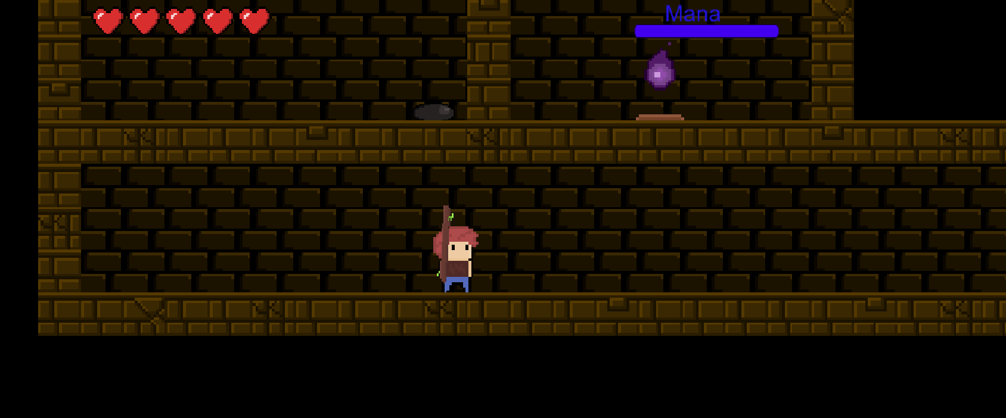

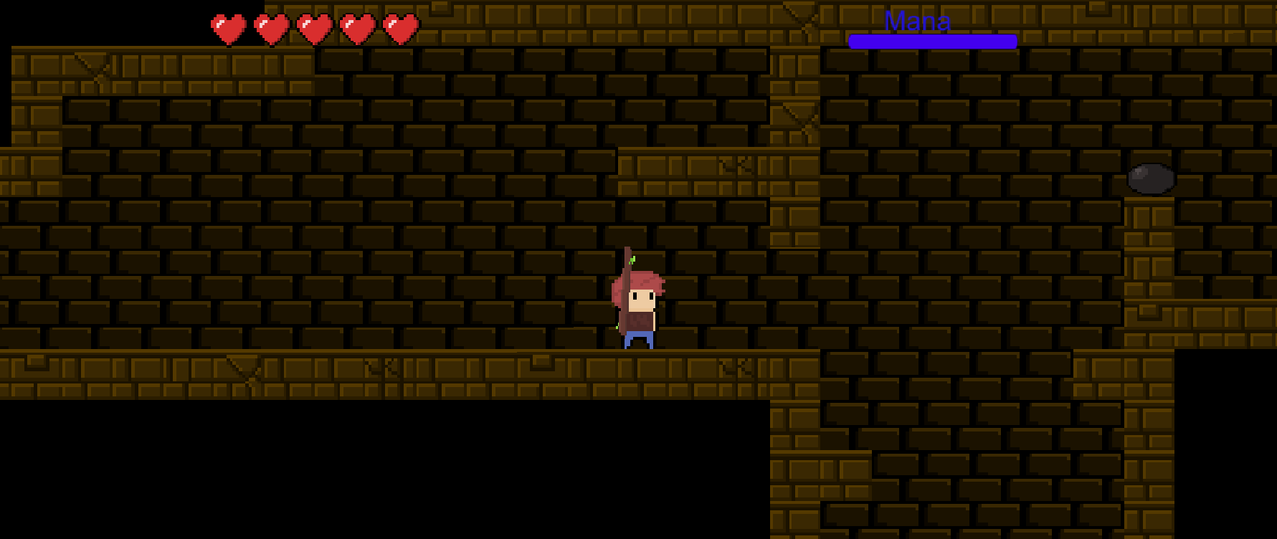

***Character*** - Simple character protagonist. Red hair; brown, ragged shirt; and blue pants. Equipped with stick at start.

***Heart Bar*** - Displays the amount of health the player has remaining. If it reaches 0 (all hearts are gone), the level restarts from the beginning.

***Mana Bar*** - Displays the amount of mana the player has remaining. Mana will automatically regenerate over time. Once the player exhausts the mana supply, the player cannot use mana-based attacks until it begins to refill.

Pause Menu

After pressing the ‘Esc’ button, the pause menu appears. Here, several options are available to the player to choose from.

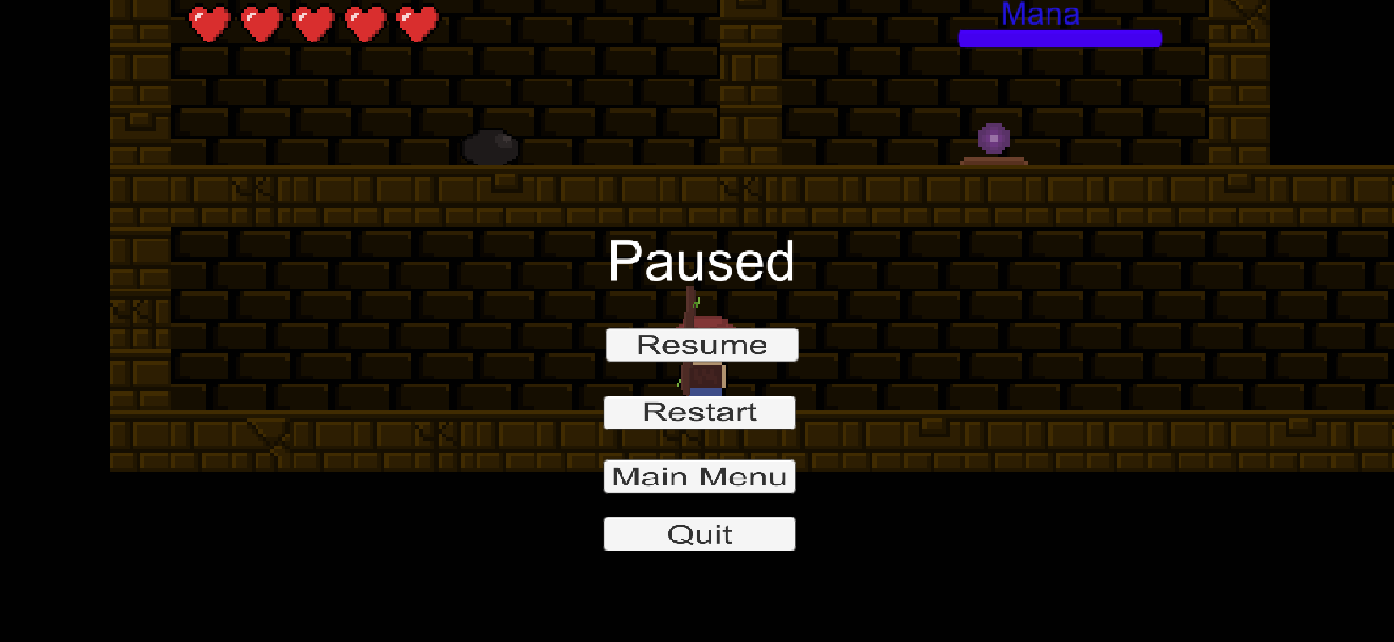

***Resume*** - Exits the pause menu and resumes the game.

***Restart*** - Restarts the current level the player is on.

***Main Menu*** -

***Quit*** - Exits the game.

In-Game Objects

In many games, there are items that the player can interact with. These can vary from unlockable abilities to pick-up items, from traps and obstacles to roaming enemies.

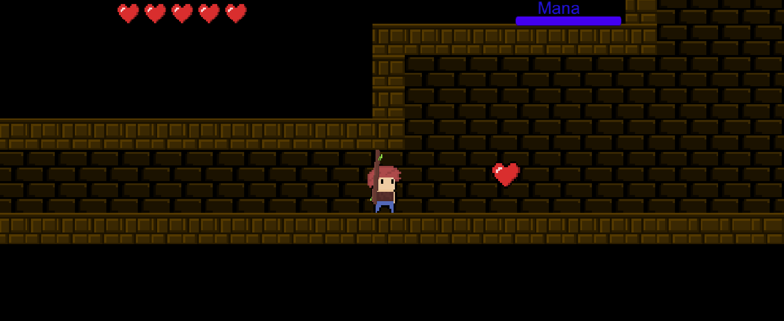

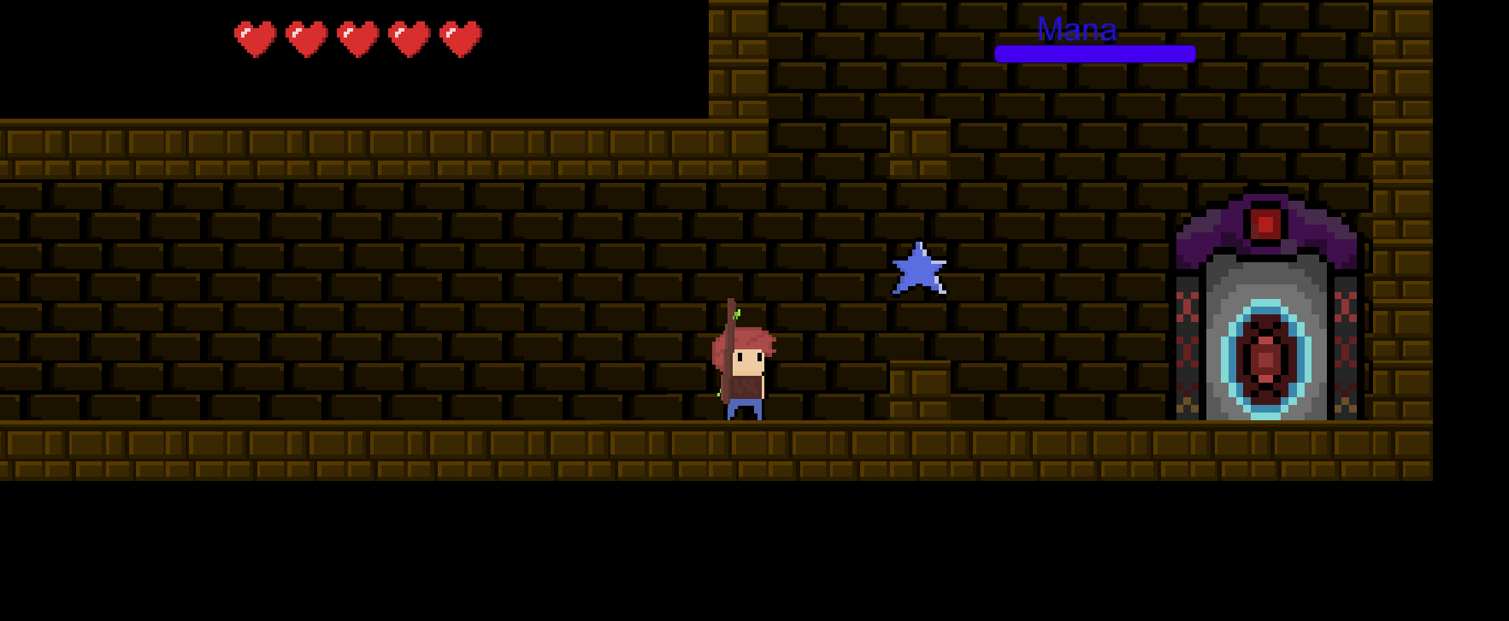

***Heart*** - Restores Health Bar to full value.

***Blue Star*** - Unlocks a magic attack.

***Portal*** - Transports the player to the next level

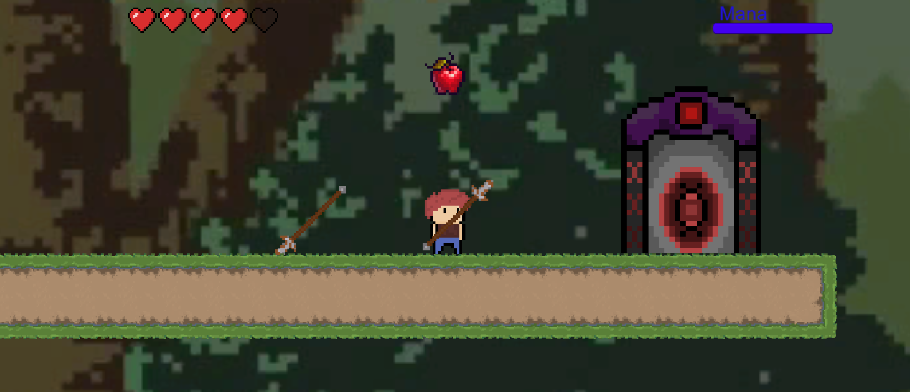

***Spear Item*** - Unlocks a spear. Once unlocked, the player can cycle between weapons. Player can press 1 to use a stick, and 2 to use a spear.

***Falling Apple*** - A unique feature of the second level. Apples fall from the sky to damage the player, so the player will have to avoid them constantly.

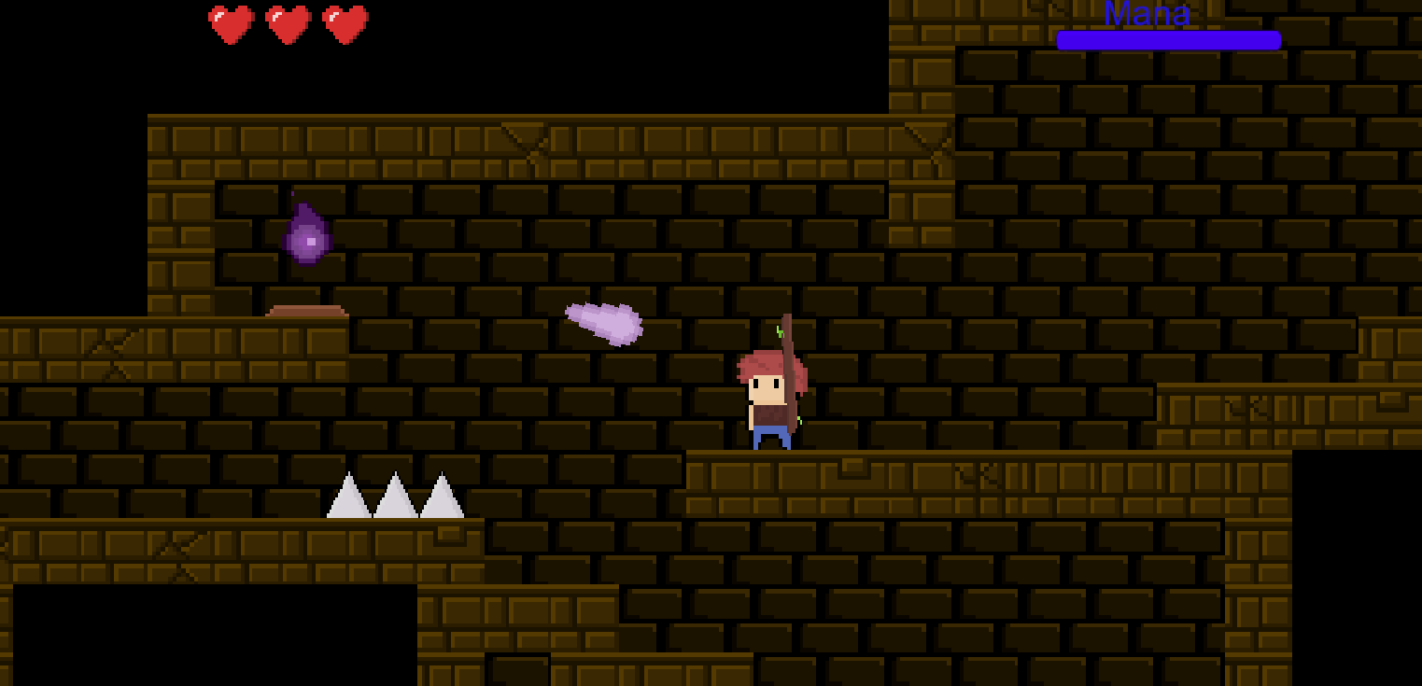

***Enemies*** - Enemies will try to stop you from escaping the stage. They can be fought or avoided, depending on the player’s play style. A turrent, purple stationary and ranged enemy, is shown in the picture as an example. There are also challenging boss monsters at the end of each stage, which cannot be avoided.

***Traps*** - One of the types of obstacles in the game. Cannot be moved/destroyed, thus, the player must evade them. Spikes are shown in the picture as an example.

**Troubleshooting**

To prevent errors, please ensure all game files are stored in the same folder before running. Missing or misplaced files may prevent the game from running at all.

The game is built to be played only on Windows platform. If your computer is not Windows based system, it will not run on your machine. The game is not hardware intensive; most of modern systems will be able to run it. If your computer is modern but is not running the game smoothly, please check if your drivers are up to date.

Lastly, if the game cannot run, try to redownload/reinstall the game over again.